*this* keyword

* Not affected by prototypes at all!
* No matter where the method is found, “this” is always the object before the dot
  + Eg. admin.fullName uses the admin object not the user object
* They will modify only their OWN states, not the state of their prototype

Example:

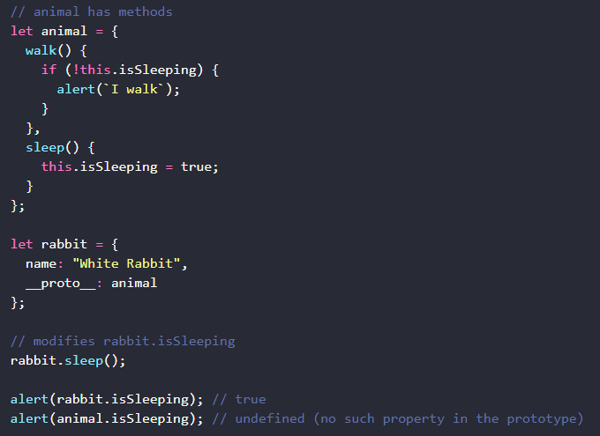

Only the rabbit has a isSleeping property because that is the only one you modify

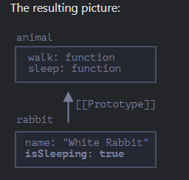

Methods are shared, but the object state is not.